Step 1. Send a sample pack
We prefer to receive a sample pack to make the process run as efficiently as possible. Before sending the sample pack, please report your request via: info@elfa.nl and include the following information:

Contact person:
Telephone number:
Your reference:
Number of packs requested:

Then send us the sample pack with your reference to Elfa. Steps 2 and 3 then no longer need to be completed.

Step 2: Photos and specifications
If it is not possible to send us a sample pack, we would like to receive 3 photos of the battery pack, 3 photos of the connector and 3 specifications. See the sample photos below. Please have at least one photo where the label is clearly legible. Then send the photos, specifications and data of the applicant to info@elfa.nl. Step 3 then no longer need to be completed.

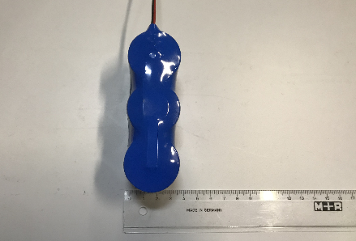
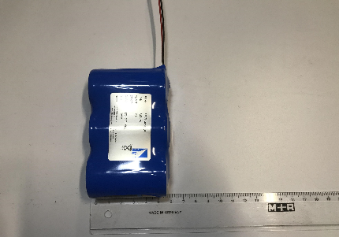
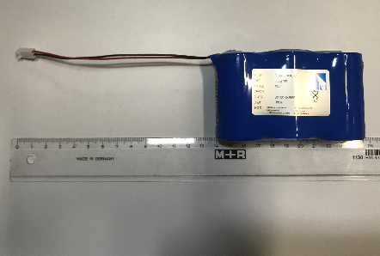
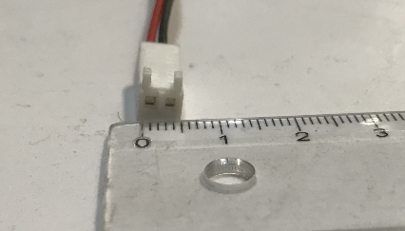
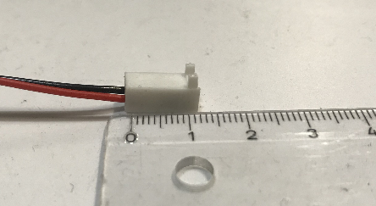
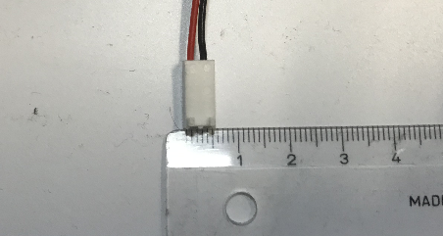
Battery pack

Connector
Specifications
Type of batteries:
Battery technology: | For example: NiCd, NiMH, Lithium, Alkaline, etc
Brand & type connector:

Details applicant
Contact person:
Telephone number:
Your reference:
Number of packs requested:
Step 3: Fill in all the specifications
If option 1 & 2 are both not possible, fill in all the information about the contact person and the required battery pack and send the completed document to info@elfa.nl.

Contact person:
Telephone number:
Your reference:
Number of packs requested:
Details applicant

Specifications:
Number of batteries:
Type of batteries:
Length pack (mm):
Width pack (mm):
Height pack (mm):
Battery technology: | For example: NiCd, NiMH, Lithium, Alkaline, etc
Voltage (V):
Capacity (mAh):
Configuration: | Stick / SBS / other
Length wire (mm)*:
Brand connector:
Type connector:
Temp. range surroundings (°C):
Number of packs requested:
Example pack possible: | Ja / Nee

*Measured from the outside of the pack to the beginning of the connector

Address information:
Elfa Elementenfabriek B.V.
Madridstraat 5-7
1175 RK Amsterdam (Lijnden)
Questions or remarks
If you still have questions and / or comments, please contact our Inside Sales department.
This can be reached through +31 (0)20 643 69 72 and info@elfa.nl.

